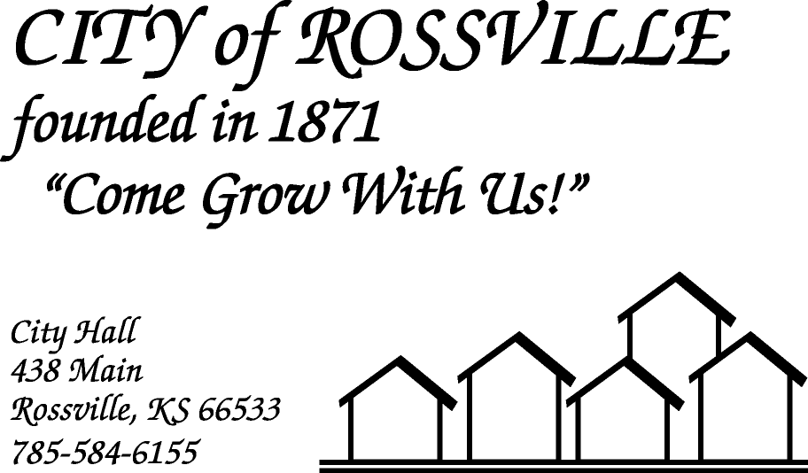

**AGENDA**

**MONDAY**

**OCTOBER 5, 2020**

***AGENDA SUBJECT TO CHANGE***

7:00 pm MINUTES

BILLS

ADOPT AGENDA

7:05 pm COUNCIL REPORT

7:15 pm UTILITY DEPT REPORT/BUSINESS

7:30 pm POLICE DEPT REPORT/BUSINESS

7:45 pm OLD BUSINESS

8:00 pm NEW BUSINESS

8:15 pm ADJOURN

**NOTE: The meeting will be online using ZOOM meeting service**

Meeting ID: 895 4281 9225  
Passcode: 349560

**Please call City Hall at 785 584-6155 if you need assistance.**